 | MONDAY | TUESDAY | WEDNESDAY | THURSDAY | FRIDAY
WEEK ONE | 23/09, 14/10 | 03/09, 24/09, 15/10 | 04/09, 25/09, 16/10 | 05/09, 26/09, 17/10 | 06/09, 27/09, 18/10
MUNCH MEAL | Oven Baked 100% Beef Burger in a bap with Chunky Chips, Sweetcorn | Roast Chicken with Roast Potatoes, Carrots, Broccoli, Sage & Onion Stuffing Ball & Gravy | Oven baked Breaded Salmon Fillet Bites with Mashed Potato, Peas | Homemade Hawaiian Pizza (with ham & pineapple) with Pasta or Salad | Pulled Pork Baps, sweet Potato fries with salad.
VEGGIE MUNCH | Oven baked Quorn Burger in a bap with Chunky Chips, Sweetcorn | Vegetable Grill with Roast Potatoes, Carrots & Broccoli | Homemade Macaroni Cheese | Jacket Potato & Cheese | Cheese & Onion Slice with mixed vegetables
MUNCHBOX | Roll with choice of filling | Sandwich with choice of filling | Wrap with choice of filling | Wrap with choice of filling | Bacon Roll or Roll with choice of filling
PUDDING | Fresh Fruit Platter | Homemade Bakewell Tart | Homemade Chocolate Cracknel | Iced Fruit Smoothie | Cookies
WEEK TWO | 09/09, 30/09 | 10/09, 01/10 | 11/09, 02/10, | 12/09, 03/10, | 13/09, 04/10,
MUNCH MEAL | Oven baked Jumbo fish finger with Mashed Potato & mixed veg | Pork Chipolata Sausages with Herby Cubes & Baked Beans or Salad | Gammon and Pineapple, New Potatoes and Peas | Homemade Cheese & Tomato Pizza with Pasta or Salad | Homemade Chicken Korma Curry (very mild creamy curry), Rice, Peas, Naan Bread
VEGGIE MUNCH | Jacket Potato & Beans | Quorn Sausage with herby cubes & beans | Homemade Vegetarian Fajitas and Tomato Salsa | Oven baked Vegetable Nuggets with Mashed Potato, Peas | Jacket Potato & Cheese & Salad
MUNCHBOX | Roll with choice of filling | Sandwich with choice of filling | Wrap with choice of filling | Wrap with choice of filling | Bacon Roll or  Roll with choice of filling
PUDDING | Devonshire Sultana Scones Mixed Fruit Jam & Cream | Homemade Fruity Flapjack | Jam Tart & Cream | Ice Cream Tub | Cookies
WEEK THREE | 16/09, 07/10 | 17/10, 08/10 | 18/09, 09/10, | 19/09, 10/10, | 20/09, 11/10,
MUNCH MEAL | Oven baked Fish Fillet with mashed potato & peas | Oven baked Chicken Fillet Bites in a Light Batter, Potato Wedges & Sweetcorn | Homemade Beef* Bolognaise Sauce with Spaghetti, Garlic Bread & Peas | Jacket Potato with Tuna, Gammon Ham or Cheese | Big Breakfast, Sausage, Bacon, Hash Browns and Baked Beans
VEGGIE MUNCH | Jacket Potato & Beans | Vegetable Nuggets & Potato Wedges with Sweetcorn | Homemade Vegetable Pasta Pot with sprinkle of cheese, Garlic Bread & Peas | Homemade Cheese & Tomato Pizza with Pasta or Salad | Veggie Big Breakfast  Vegie Sausage, Hash Browns & Beans
MUNCHBOX | Roll with choice of filling | Sandwich with choice of filling. | Wrap with choice of filling | Wrap with choice of filling | Bacon Roll  Or Roll with choice of filling
PUDDING | Homemade Chocolate Coated Bun | Meringue Nests with Sliced Peaches | Homemade Ginger Shortie | Homemade Madeleine Sponge | Cookies
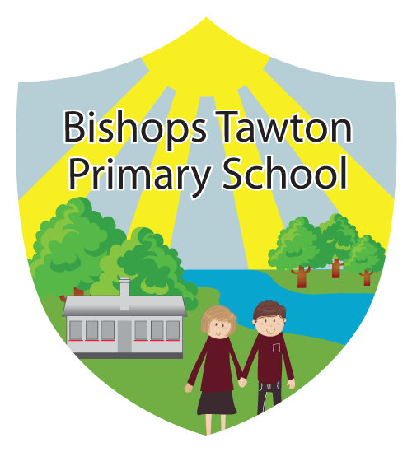
£2.20
MUNCH TIME MENU AUTUMN TERM
AVAILABLE EACH DAY: SALAD BAR, FRESH FRUIT, BREAD, YOGHURT, MILK AND WATER.
ALL MEALS PROVIDED WITH THE PUDDING OPTION AND A DRINK.
*All Items subject to availability

