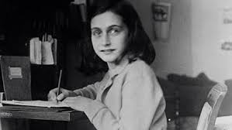
ANNE FRANK
Have you ever imagined what isolation and starvation would feel like only because you have been born into a certain religion? Well in 1939-1945 for Jews this was the new normal! This was reality for Anne Frank, a 13 year old Jewish girl who lived in Germany when Adolf Hitler was in power.

Frankfurt, Germany, June 12th 1929 a girl under the name of Annelise Marie Frank, born as a Jew, had become a new being to the world. She grew up to be a caring, educated girl, but in 1933 Anne and her family-Margot, Edith and Otto-moved to her Dad’s business because Adolf Hitler had come to power and persecuted Jewish people.

So in 1942, the frank family and three other people known as the ‘Van Pels’, hid behind Otto Frank’s company in an attex behind a book shelf. Despite their hiding in 1944, they were discovered and sent away to Bergen-Belsen’s concentration camp. Unfortunately, Anne and Margot were killed of a disease called typhus on February 1945 and Edith died of starvation only 2 weeks before liberation on April 15th 1945. Otto Frank survived and in 1947 he published his daughter’s diary to let everyone know how traumatic their experience was! Sadly, Otto Frank lived alone until the age of 91.
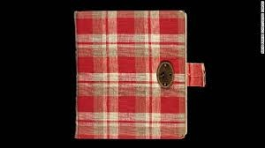
Anne Frank’s diary says not only about her experience, but her feelings and how to never give up no matter the situation. She also teaches our generation that our isolation isn’t that bad and we should be grateful on what we have now compared to other people.

