 | MONDAY | TUESDAY | WEDNESDAY | THURSDAY | FRIDAY
WEEK ONE | 13/05, 17/06, 08/07 | 23/04, 14/05, 18/06, 09/07 | 24/04, 15/05, 19/06, 10/07 | 25/04, 16/05, 20/06, 11/07 | 26/04, 17/05, 21/06, 12/07
MUNCH MEAL | Homemade Hawaiian Pizza (with ham & pineapple) with Pasta or Salad | Roast Chicken with Roast Potatoes, Carrots, Broccoli, Sage & Onion Stuffing Ball & Gravy | Oven baked Breaded Salmon Fillet Bites with Mashed Potato, Peas | Oven Baked 100% Beef Burger in a bap with Chunky Chips, Sweetcorn | Homemade Sweet & Sour Chicken with mixed vegetables & Noodles & Chinese Crackers
VEGGIE MUNCH | Jacket Potato & Cheese | Vegetable Grill with Roast Potatoes, Carrots & Broccoli | Oven baked Vegetable Nuggets with Mashed Potato, Peas | Oven baked Quorn Burger in a bap with Chunky Chips, Sweetcorn | Cheese & Onion Slice with mixed vegetables
MUNCHBOX | Roll with choice of filling | Sandwich with choice of filling | Wrap with choice of filling | Wrap with choice of filling | Bacon Roll or Roll with choice of filling
PUDDING | Fresh Fruit Platter | Homemade Bakewell Tart | Homemade Chocolate Cracknel | Iced Fruit Smoothie | Jelly Pot
WEEK TWO | 29/04, 20/05, 24/06, 15/07 | 30/04, 21/05, 25/06, 16/07 | 01/05, 22/05, 26/06, 17/07 | 02/05, 23/05, 27/06, 18/07 | 03/05, 24/05, 28/06, 19/07
MUNCH MEAL | Oven baked Jumbo fish finger with Mashed Potato & mixed veg | Pork Chipolata Sausages with Herby Cubes & Baked Beans or Salad | Homemade Chicken* Fajitas and Tomato Salsa | Homemade Cheese & Tomato Pizza with Pasta or Salad | Homemade Chicken Korma Curry (very mild creamy curry), Rice, Peas, Naan Bread
VEGGIE MUNCH | Jacket Potato & Beans | Quorn Sausage with herby cubes & beans | Homemade Vegetarian Fajitas and Tomato Salsa | Homemade Macaroni Cheese | Jacket Potato & Cheese & Salad
MUNCHBOX | Roll with choice of filling | Sandwich with choice of filling | Wrap with choice of filling | Wrap with choice of filling | Bacon Roll or  Roll with choice of filling
PUDDING | Devonshire Sultana Scones Mixed Fruit Jam & Cream | Homemade Fruity Flapjack | Jam Tart & Cream | Ice Cream Tub | Jelly Pot
WEEK THREE | 10/06, 01/07 | 07/05, 11/06, 02/07 | 08/05, 12/06, 03/07 | 09/05, 13/06, 04/07 | 10/05, 14/06, 05/07
MUNCH MEAL | Oven baked Fish Fillet with mashed potato & peas | Oven baked Chicken Fillet Bites in a Light Batter, Potato Wedges & Sweetcorn | Homemade Beef* Bolognaise Sauce with Spaghetti, Garlic Bread & Peas | Jacket Potato with Tuna, Gammon Ham or Cheese | Big Breakfast, Sausage, Bacon, Hash Browns, Tomatoes and Baked Beans
VEGGIE MUNCH | Jacket Potato & Beans | Vegetable Nuggets & Potato Wedges with Sweetcorn | Homemade Vegetable Pasta Pot with sprinkle of cheese, Garlic Bread & Peas | Homemade Cheese & Tomato Pizza with Pasta or Salad | Veggie Big Breakfast  Vegie Sausage, Hash Browns, Tomatoes & Beans
MUNCHBOX | Roll with choice of filling | Sandwich with choice of filling. | Wrap with choice of filling | Wrap with choice of filling | Bacon Roll  Or Roll with choice of filling
PUDDING | Homemade Chocolate Coated Bun | Meringue Nests with Sliced Peaches | Homemade Ginger Shortie | Homemade Madeleine Sponge | Jelly Pot
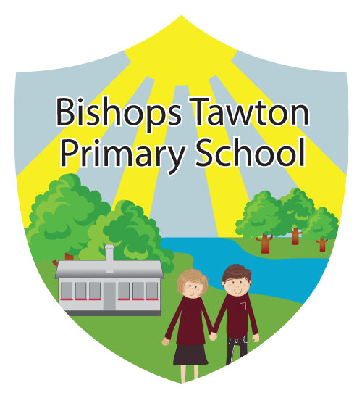
£2.20
MUNCH TIME MENU SUMMER TERM
AVAILABLE EACH DAY: SALAD BAR, FRESH FRUIT, BREAD, YOGHURT, MILK AND WATER.
ALL MEALS PROVIDED WITH THE PUDDING OPTION AND A DRINK.
*All Items subject to availability

