Victory in Europe Day, (VE day)
- VE Day is when we celebrate the victory in world war II of Nazi Germanys unconditional surrender of its armed forces on 8th of May1945.
- Various events were organised to mark the occasion, including parades, thanksgiving services and street parties.
- The Royal Family also played a central role in London’s Victory Celebrations.
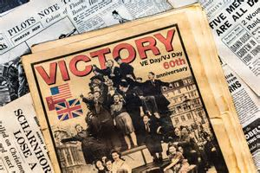
- It is the 75th anniversary of VE day! Over one million people celebrate in the streets of cities, towns and villages.
- Large groups of people would gather in Trafalgar Square, waiting for Winston Churchill.
