Bishops Tawton Primary School and Pre-School
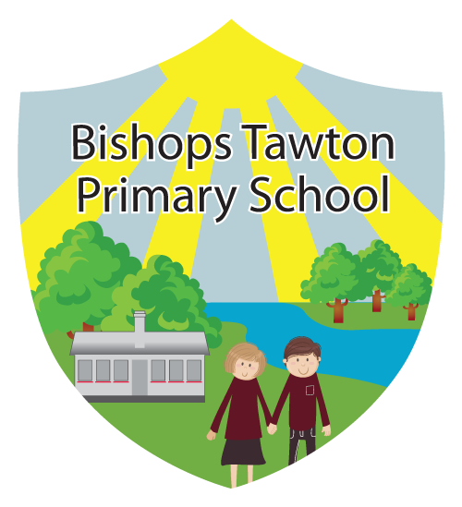
Talk to us…
Safeguarding

‘Keeping children safe is everybody’s responsibility’

All of our school and pre-school staff are trained to Level 2 in safeguarding, in addition to this:
Our designated safeguarding team are:
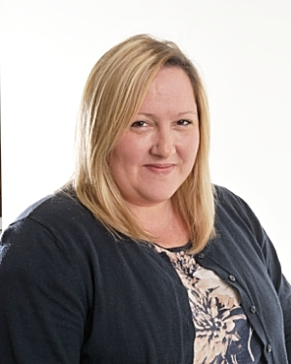
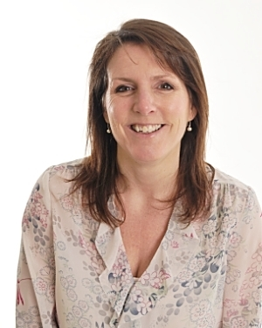
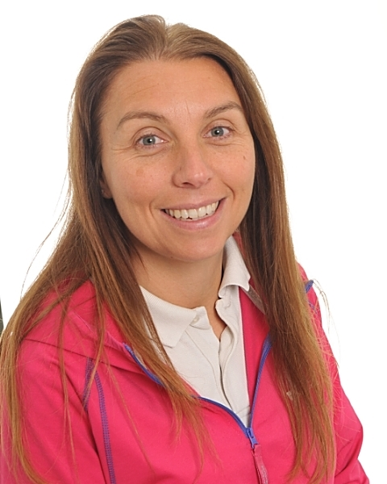
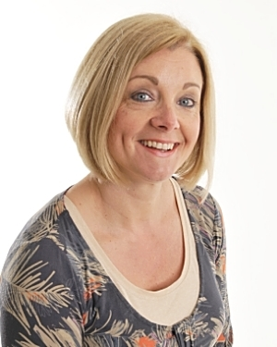

Safeguarding Lead
Level 3
Mrs Debbie Passmore
HLTA/Parent Support
Designated Safeguarding Lead
Level 3
Mrs Melanie Smallwood
Head Teacher
Deputy Designated Safeguarding Lead
Level 3
Mrs Karen Lintin
Class Teacher
Safeguarding Lead
Level 3
Mrs Donna Clark
SENDco

Is something worrying you?
Talk to us…

Are you concerned about a child?

It is our responsibility to keep children safe. You can also call the Multi Agency Safeguarding Hub (MASH) if you have genuine concerns about the safety of a child either in the school or home setting: 03451551071

