SAM PILGRIM
Have you ever imagined speeding down dirt trails and doing amazing stunts? This is exactly what Sam Pilgrim does for a living and at the age of 23 it led to him winning the FMB World Tour. It was the greatest achievement because he was the first European athlete to win a gold medal.

In 2004 Sam entered his first competition Filthy 48. At only 14 he won gold it was obvious he was born to be a star. After a few years he went into his first full year of international racing which cemented how amazing he was. After that he continued with more competitions.
He continued to progress in 2008 when he won Nissan Qashqai Urban Challenge in London and won further victories at 2010 and 2011 White style in Leogang.
In 2013 he became the first European Athlete to win FMB world tour. Such a great achievement from Sam on that day. Later he became famous for lots of other things including back flip tail whip.

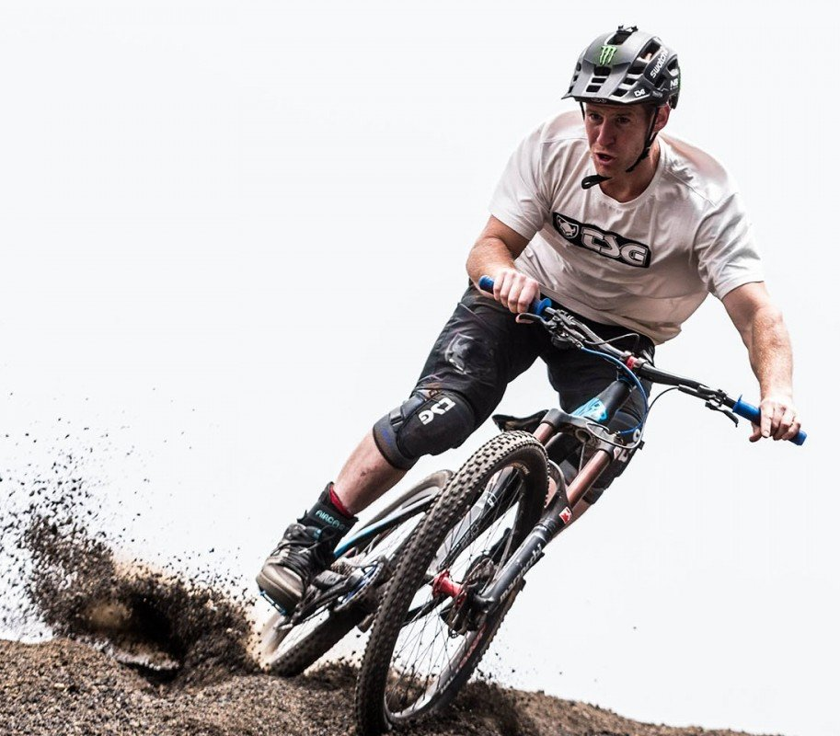
Who would have ever thought a young boy from Colchester Essex could become this famous? He continues to travel the world and inspire other young children.

